# **Feistel Structure**

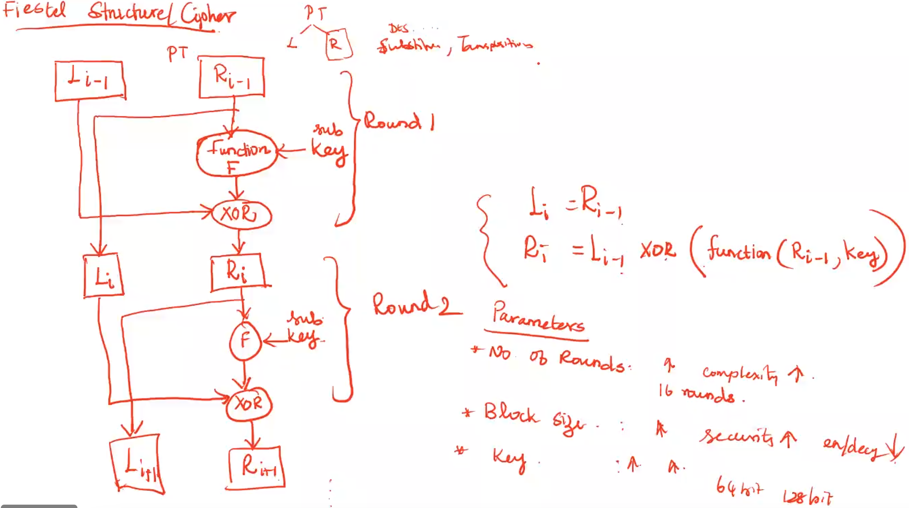

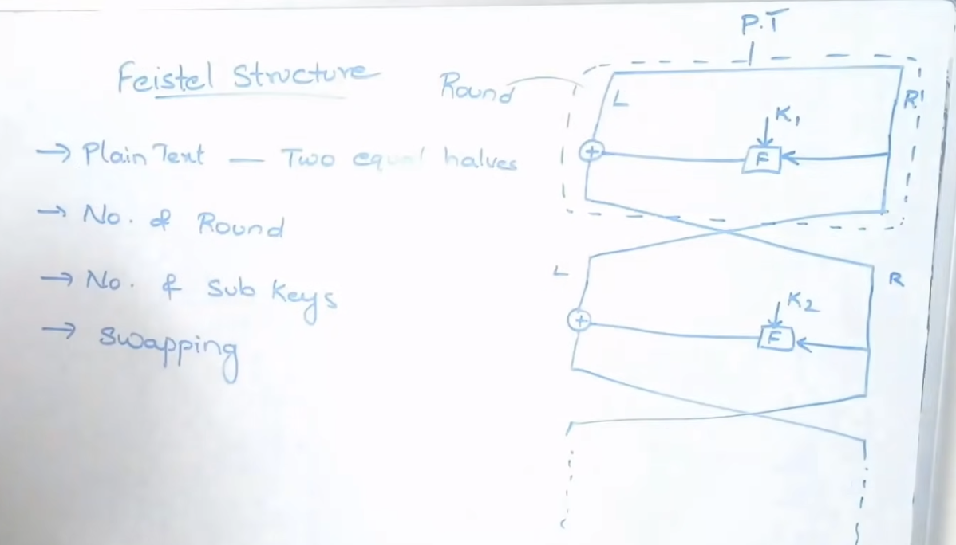

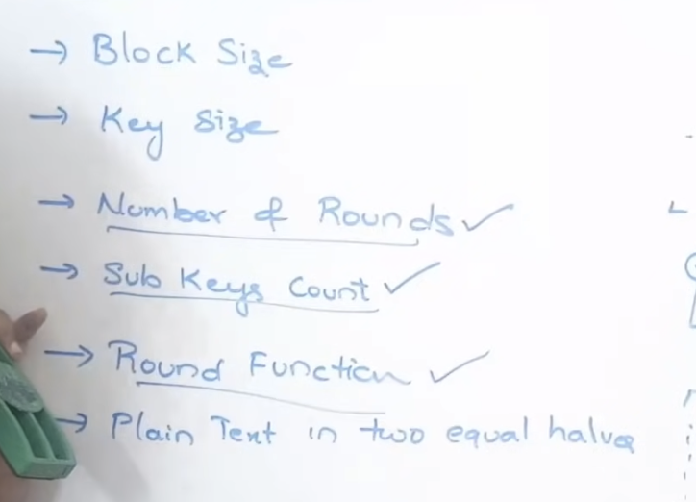

If the Round function is more complex 🡪 the process will be very strong.

**

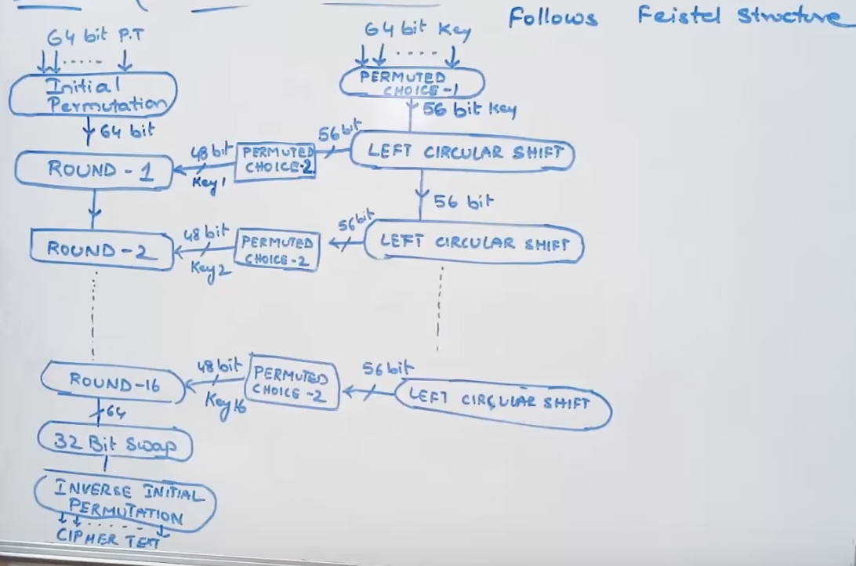

32 bit swap (Exchanging 2 equal 32 halves)  
1st 32 bits to the RHS  
2nd 32 bits to the LHS

What is happening in each Round ??

Expansion Permutation 🡪 Additional 16 bits will be added.

Permuted Choice-2 (Contraction) 🡪 8 bits are reduced.

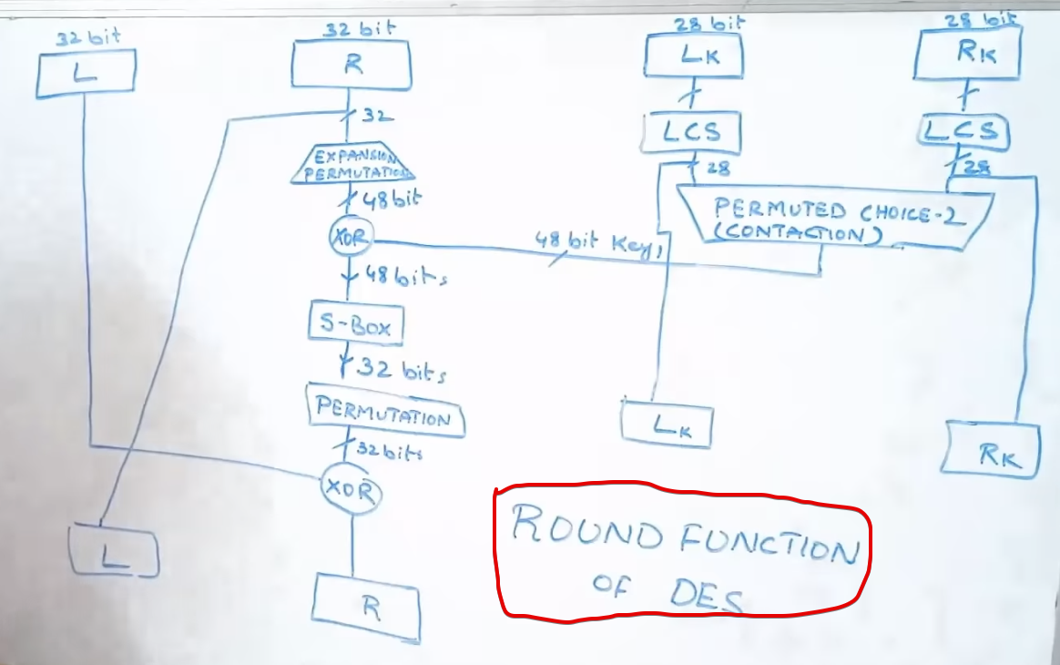

## **Initial Permutation for Plain Text**

Input 🡪 plain text (64bits)  
Output 🡪 permuted text(64 bits)

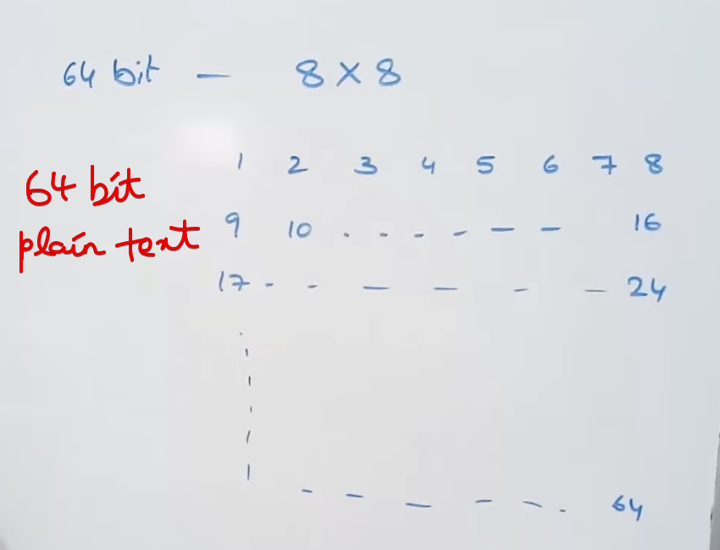

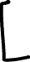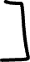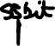

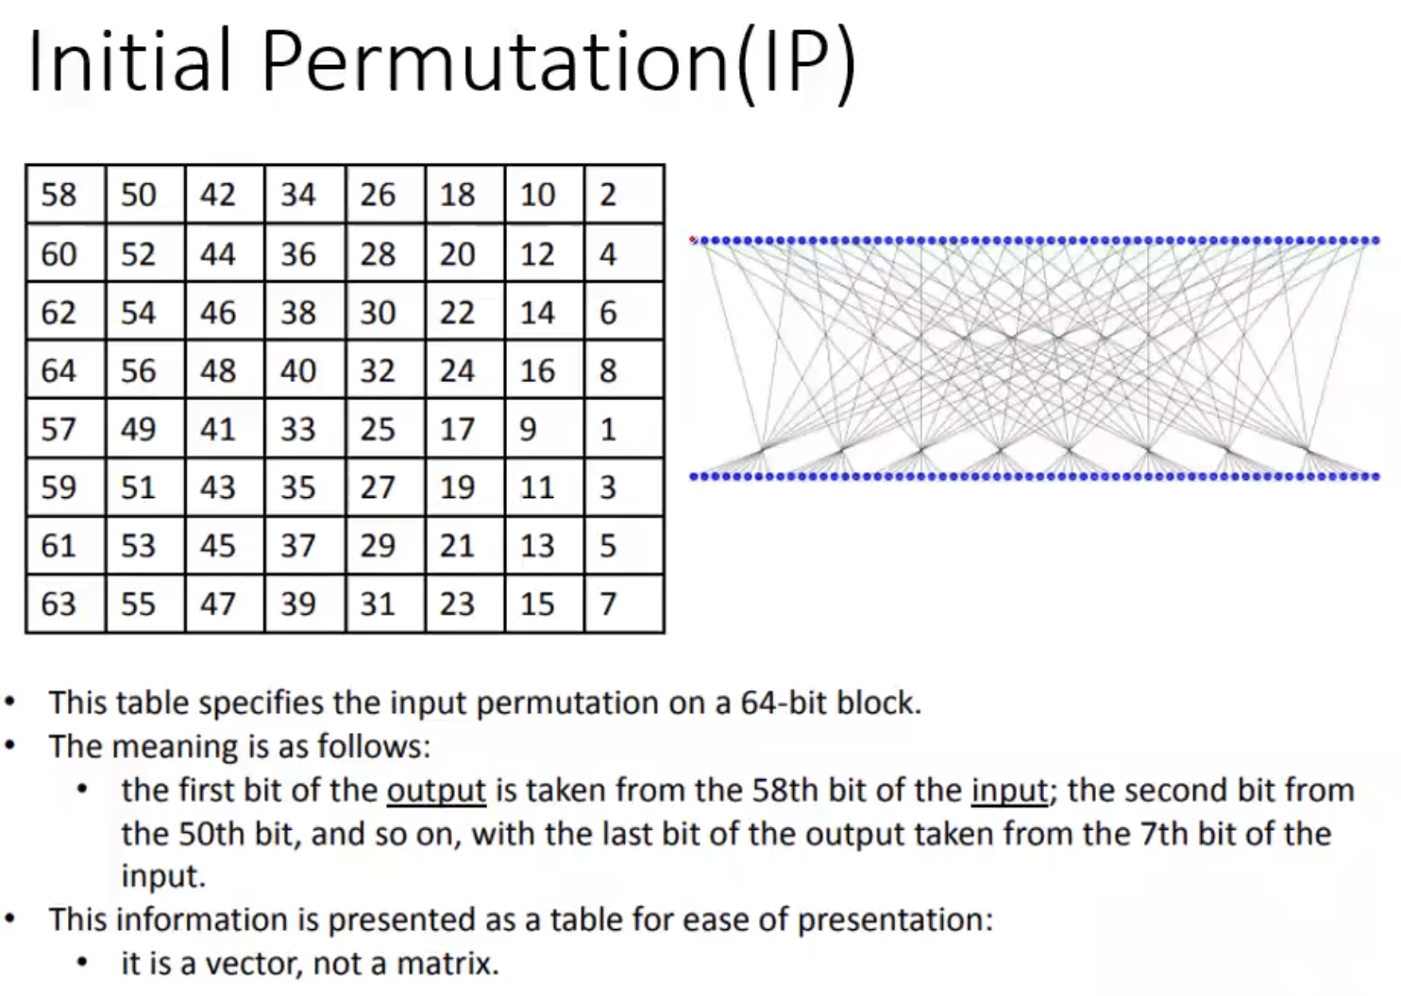

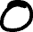

After Initial Permutation

Matrix[0][0] 🡪 58th bit of the Plain text   
Matrix[0][1] 🡪 50th bit of the Plain text

**This matrix(64bits) is give as input to the Round-1**

## **Round-1**

Input 🡪 Initial Permuted plain text (64bits)  
Output 🡪

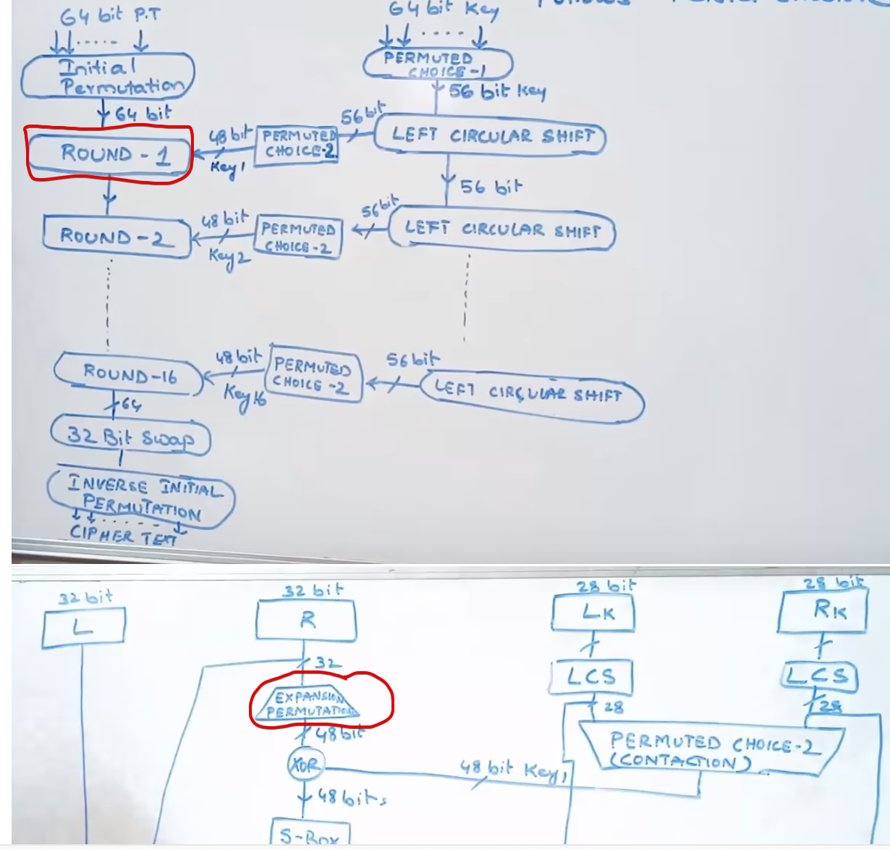

Split the text into Left-32 bits and Right-32 bits.  
Right-32 bits 🡪 Expansion/Permutation table 🡪 48bits

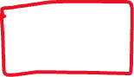

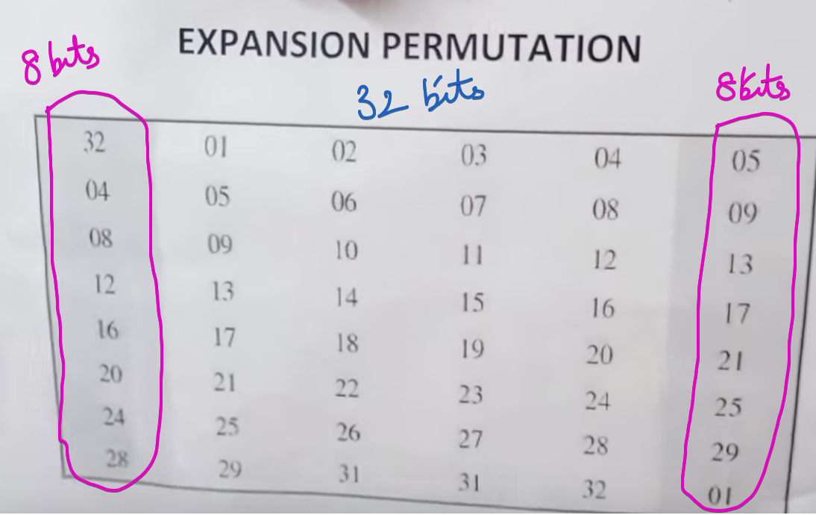

The total output 🡪 48bits.

This output must be XOR with the Permuted Choice-2 of the security key.

## **Permuted Choice-1 for Key**

Input 🡪 key (64bits)  
Output 🡪 key(56 bits)

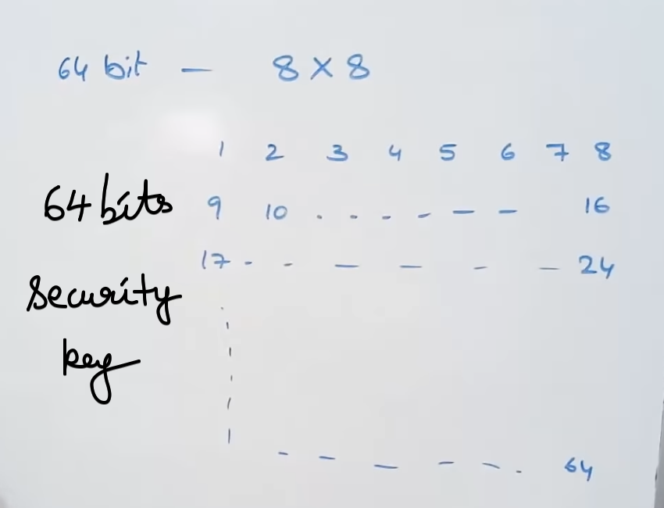



In This table, multiples of 8 have been removed.

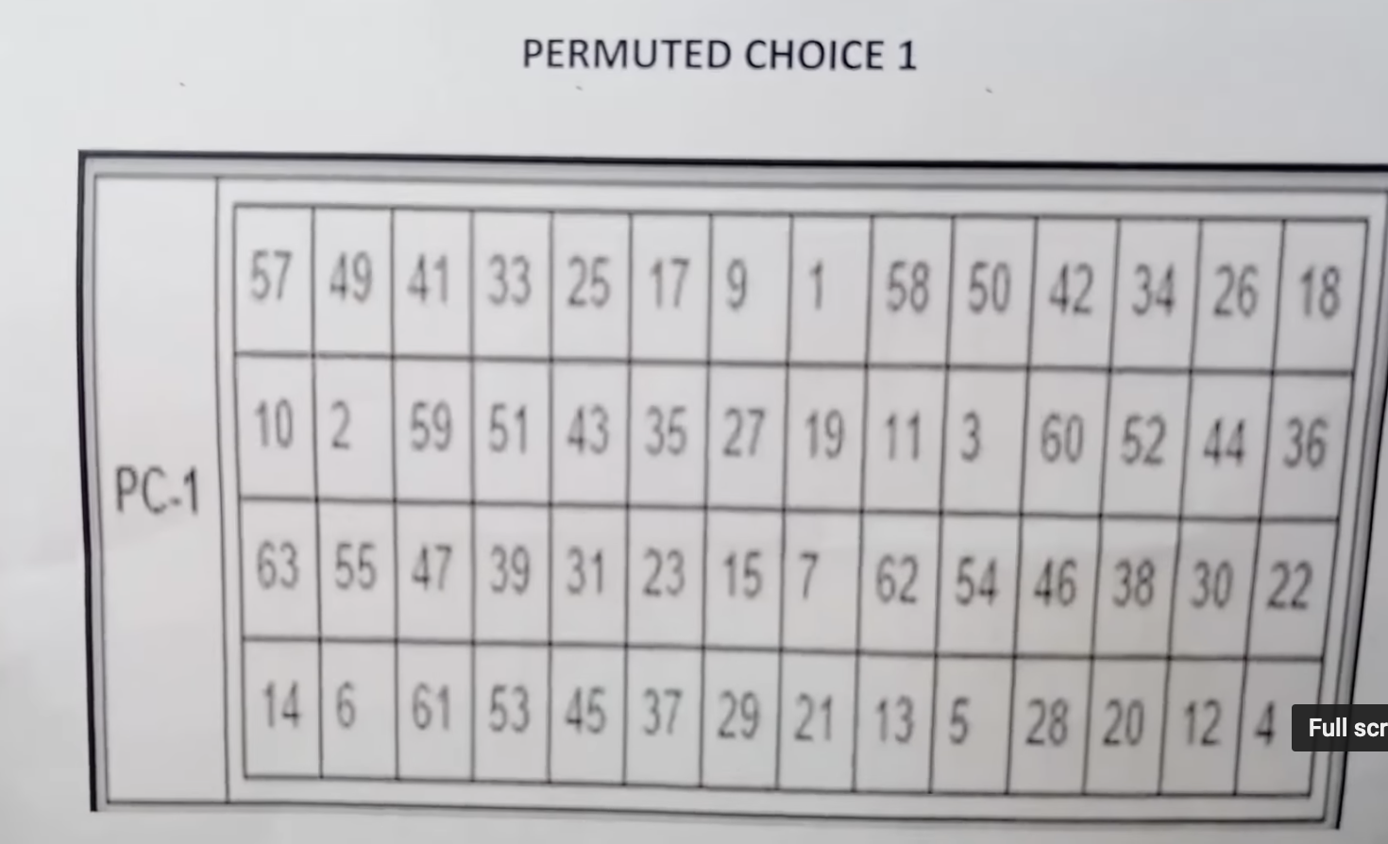

**This Permuted Choice-1 (56bits) is give as input to the Left Circular Shift**

## **Left Circular Shift for Permuted Key**

Input 🡪 Permuted key (56bits)  
Output 🡪 Left circular shifted key(56 bits)

After Permuted, the key will be split into 2 parts(28 bits each) 🡪 input to the 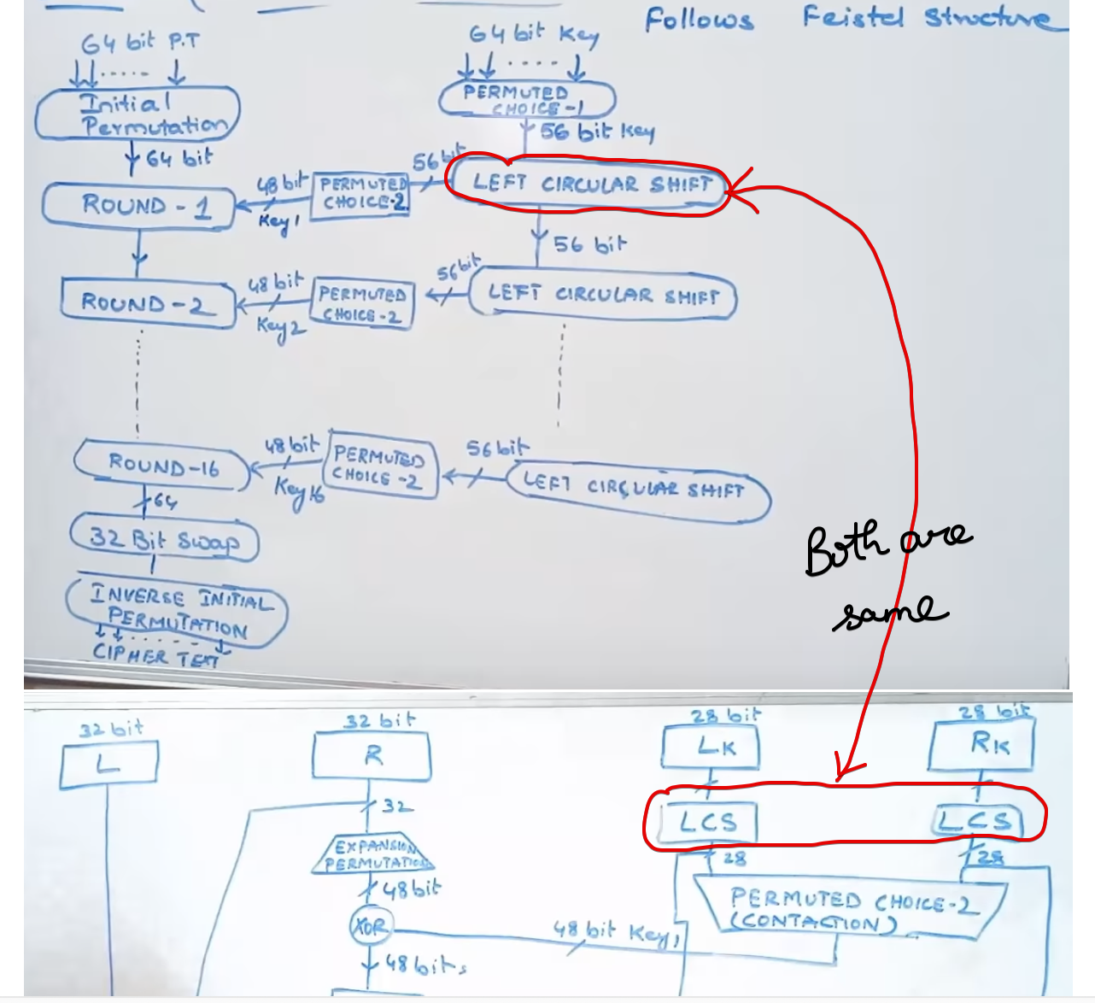   
left circular shift.



The number of shifts depends upon the round number.

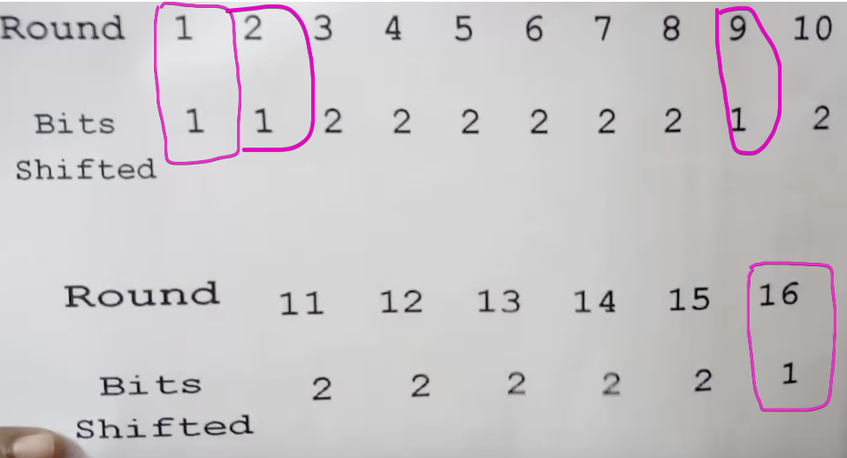



Round-1,2,9 and 16 🡪 1 bit shift  
Rest of the rounds 🡪 2 bits shift

**After shifting, LCS(28bits) and LCS(28 bits) are given to Permuted Choice-2**

## **Permutation Choice -2 / Contraction**

Input 🡪 Left Circular Shift(28bits) and Left Circular Shift(28bits) -> Total 56bits  
Output 🡪 Permuted key(48 bits)

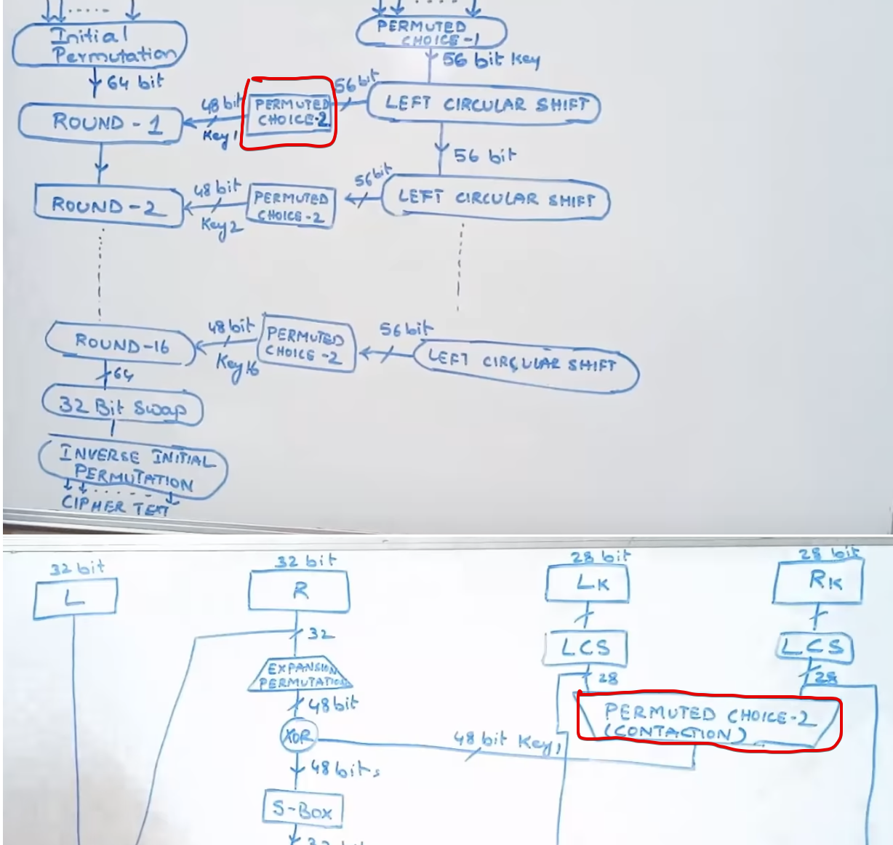



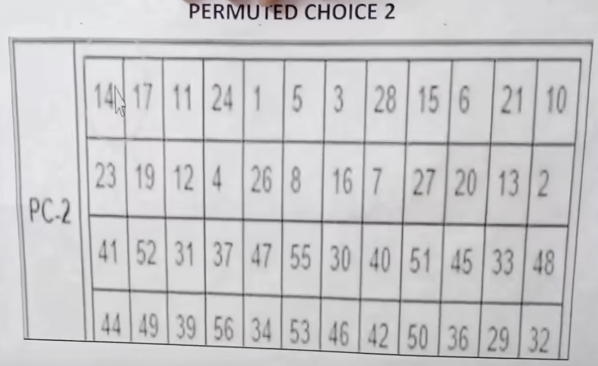  
This 48 bits output.



**After permutation, 48 bits are fed to XOR.**

## **XOR Operation-1**

Expansion Permutation of plain text (48bits)   
**XOR** Permuted Choice -2 of the key (48bits)

Output 🡪 48bits XOR answer

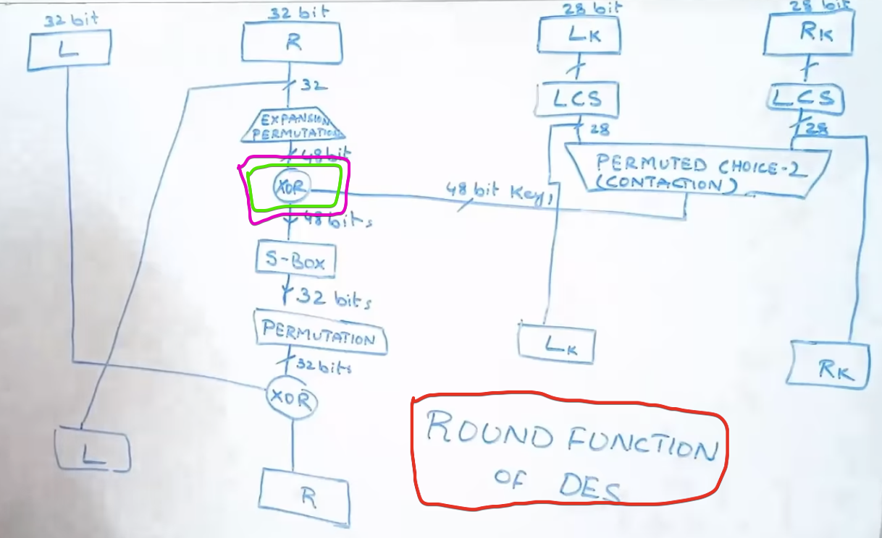

**After XOR operation, 48 bits are fed to S-Box.**

## **S-Box**

Input 🡪 48 bits from XOR operation.  
Output 🡪 32 bits from S-Box.

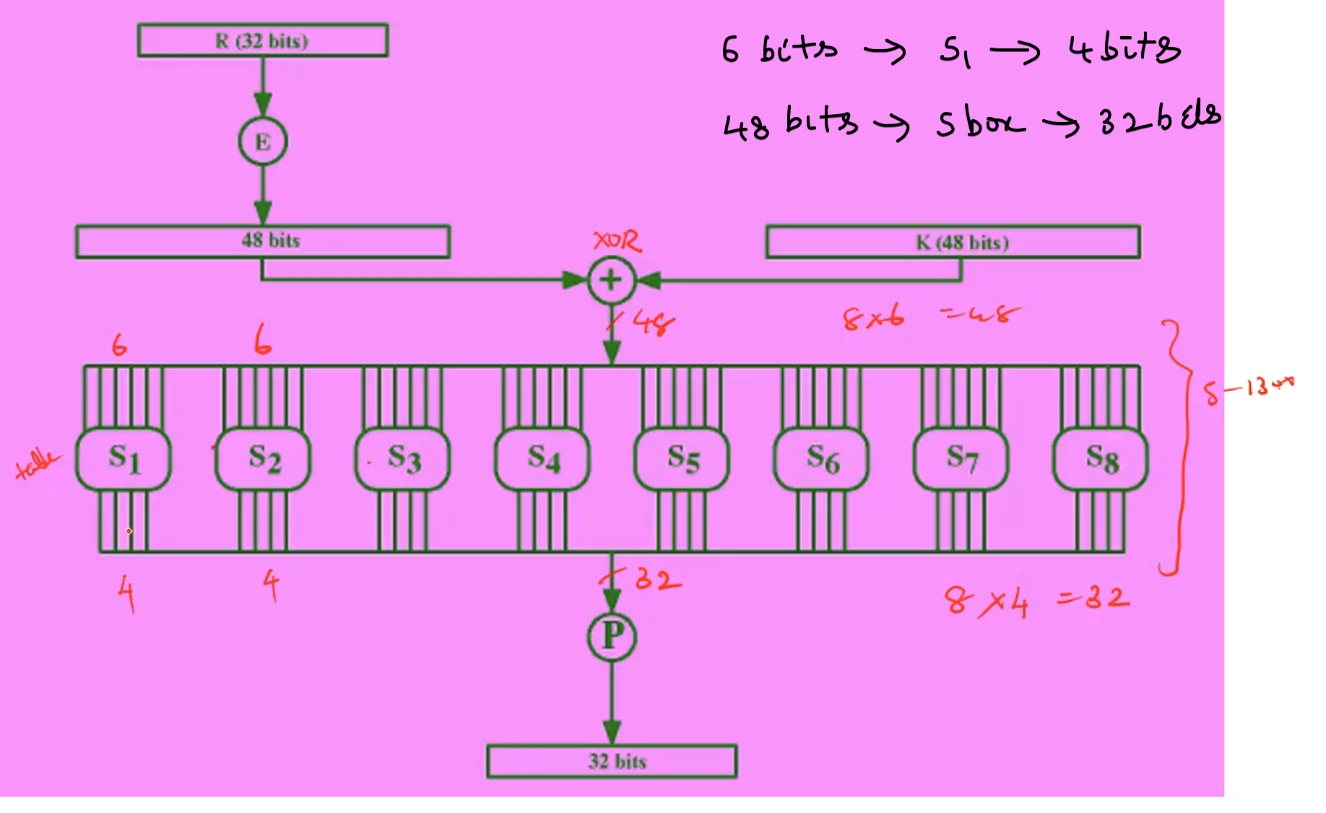

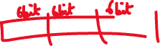

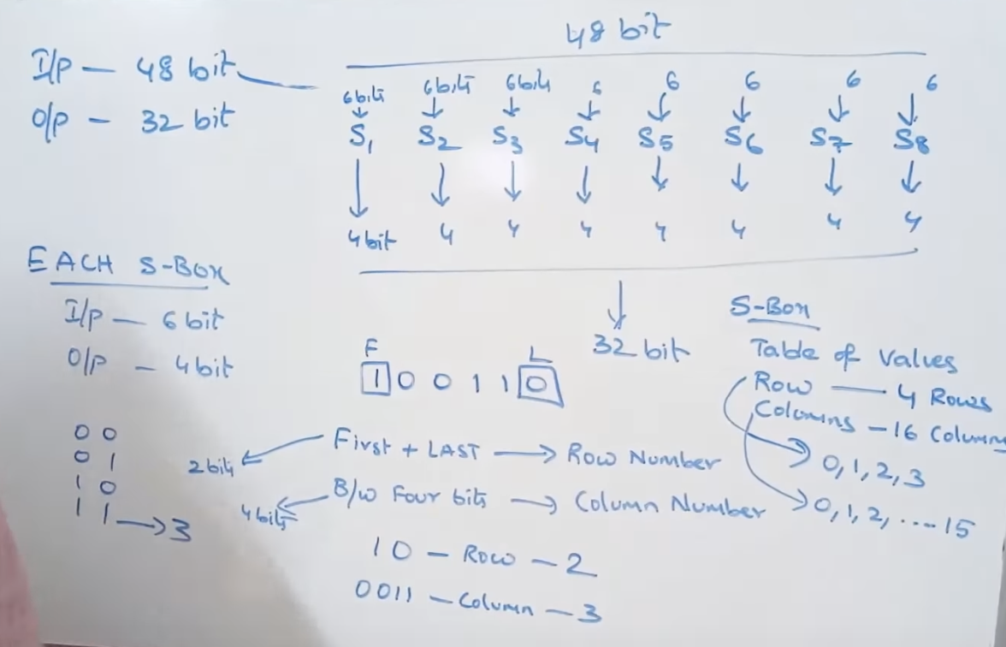



Row number 🡪 2 bits(4 combinations)  
Column number 🡪 4 bits (16 combinations)



Lets take an example mentioned,

The input to S1 🡪 100110 [ 6 bit input ]  
First digit is 1 and Last digit is 0  
(First + Last)bits Row-10 🡪 2  
B/w Four bits Col-0011 🡪 3



Looking into S1 table 2nd row and 3rd column,  
the element is 8 🡪 then to 1000(binary) [ 4 bit output ]

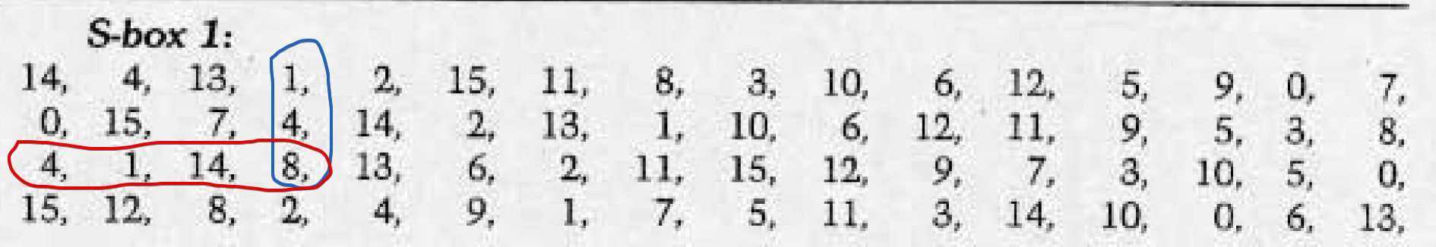



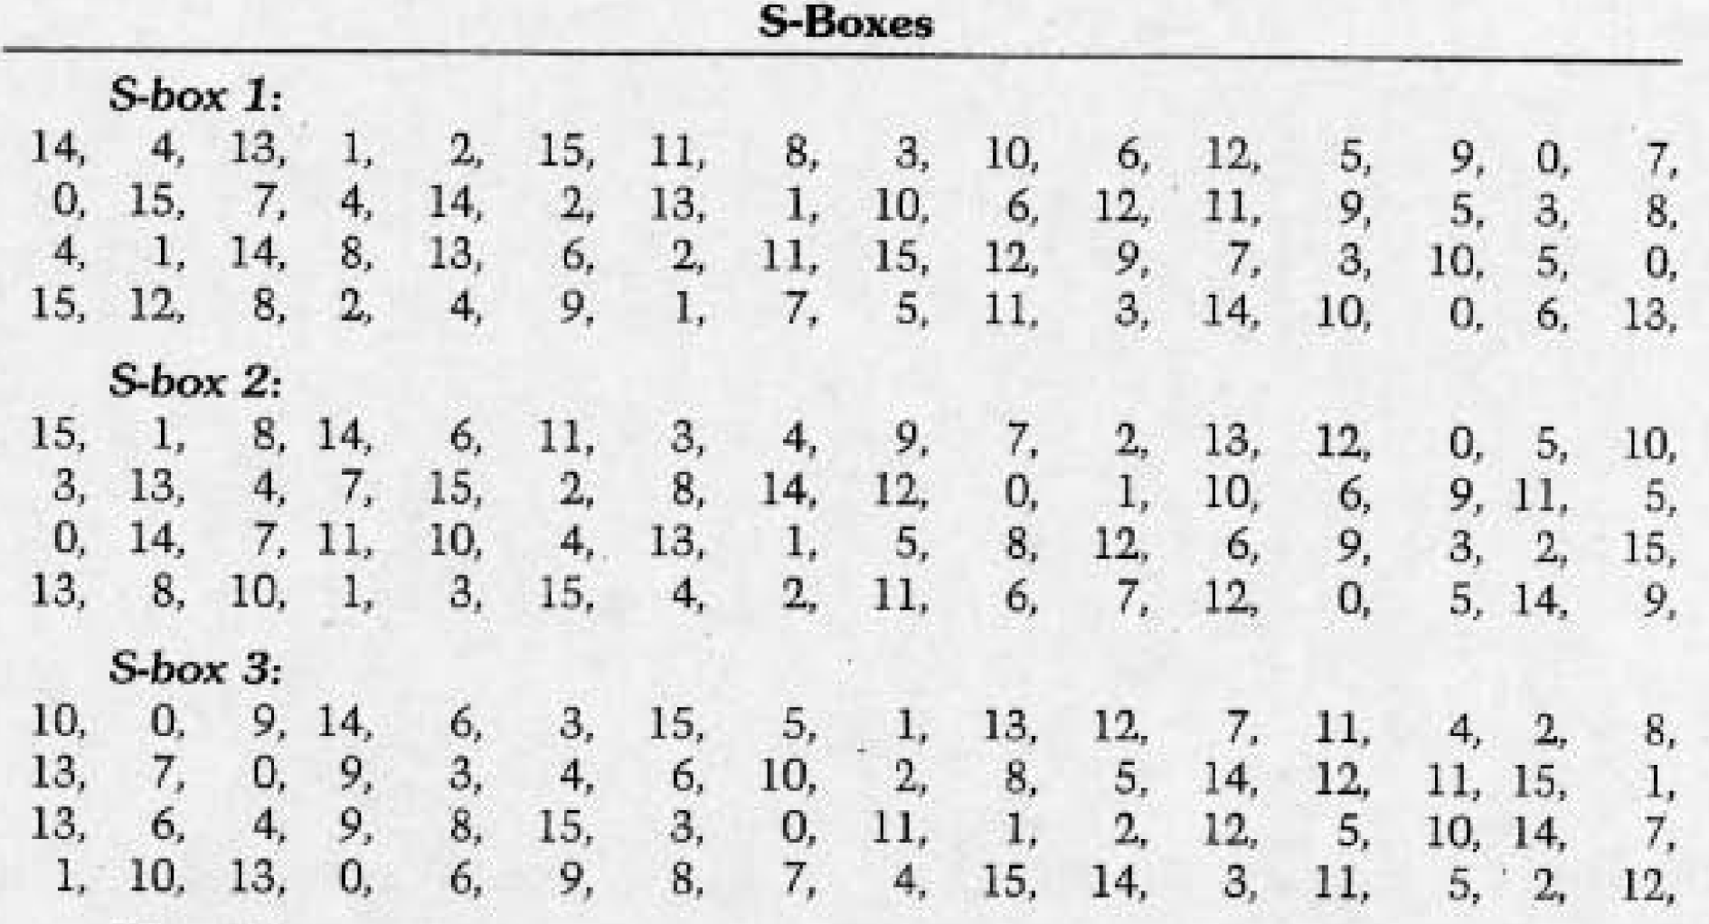  
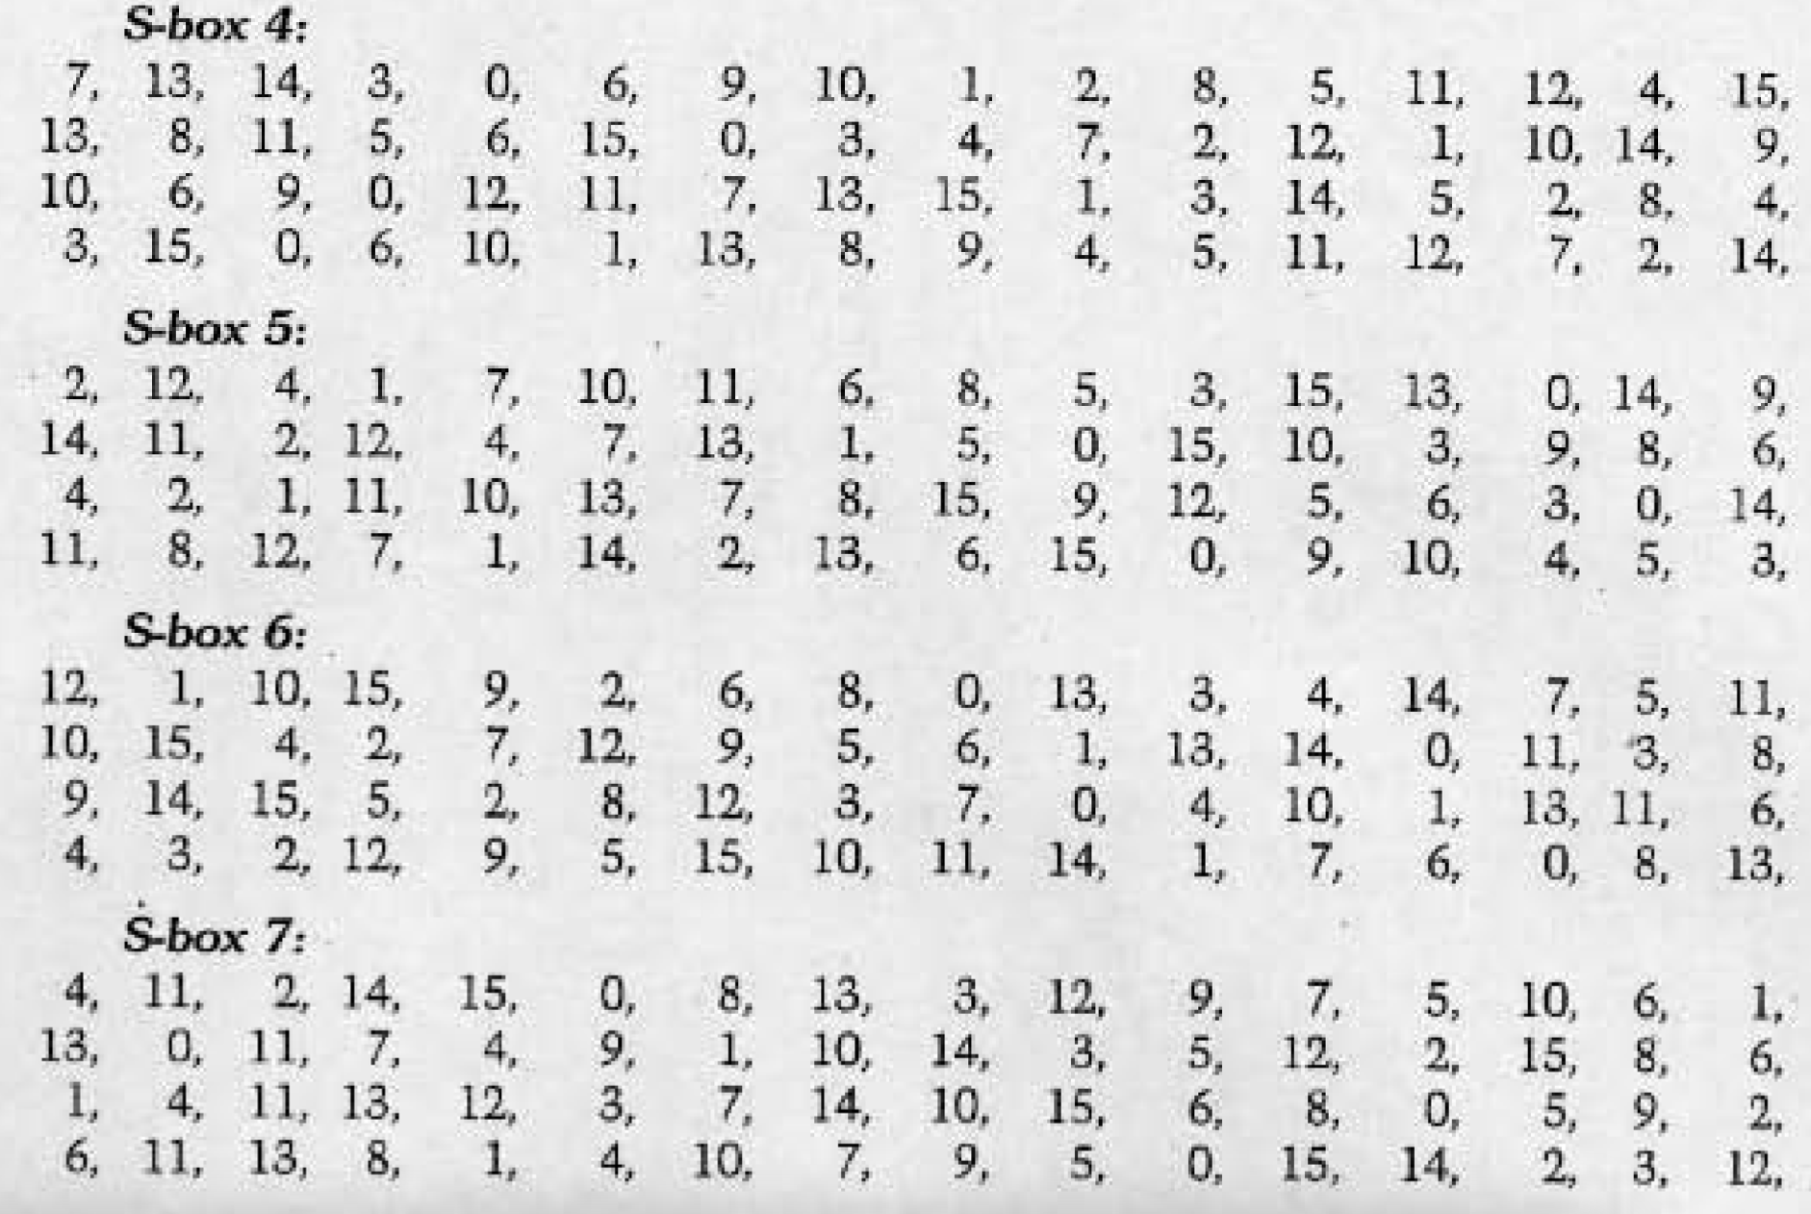  
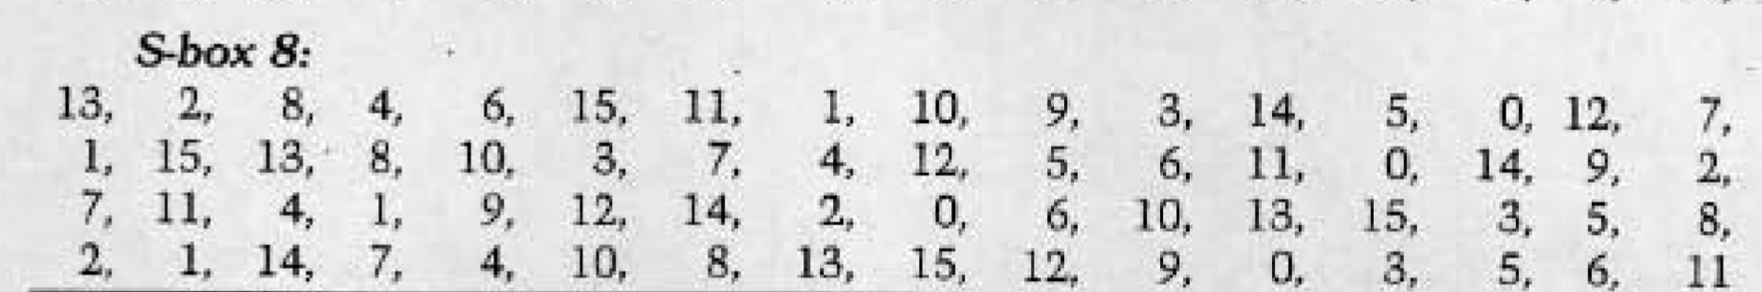



**After S-Box operation the Output 🡪 32 bits is fed into Permutation Matrix**

## **Permutation**

Input 🡪 32 bits from S-Box  
Output 🡪 32 bits

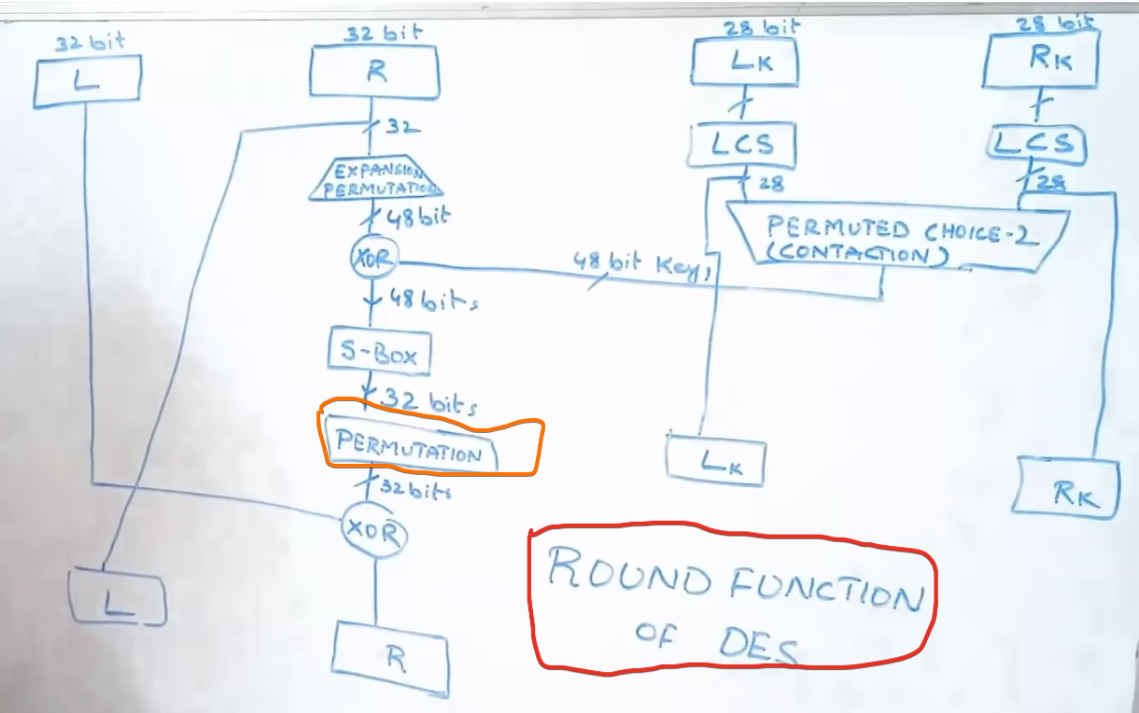



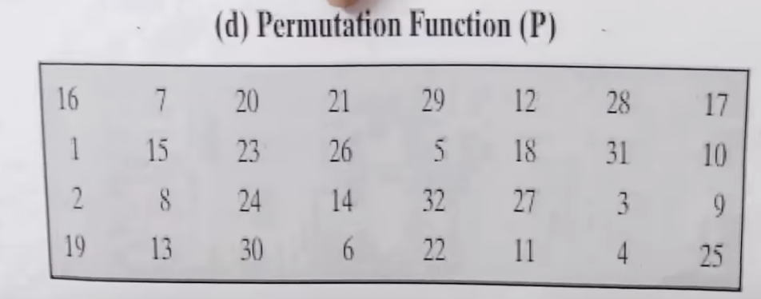



Just interchanging the bits

**After S-Box operation the Output 🡪 32 bits is fed into Permutation Matrix**



## **XOR Operation-2**

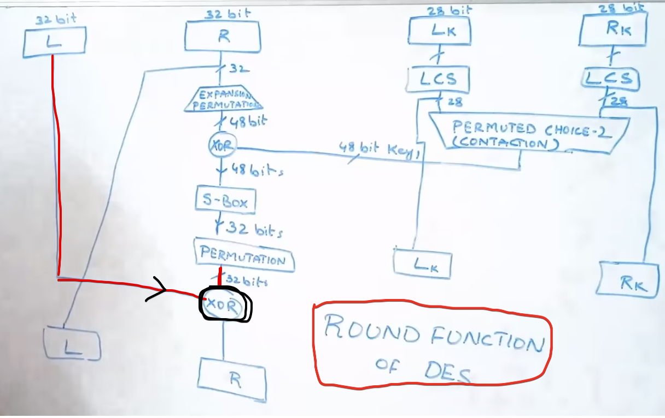

## **Inputs for Round-2**

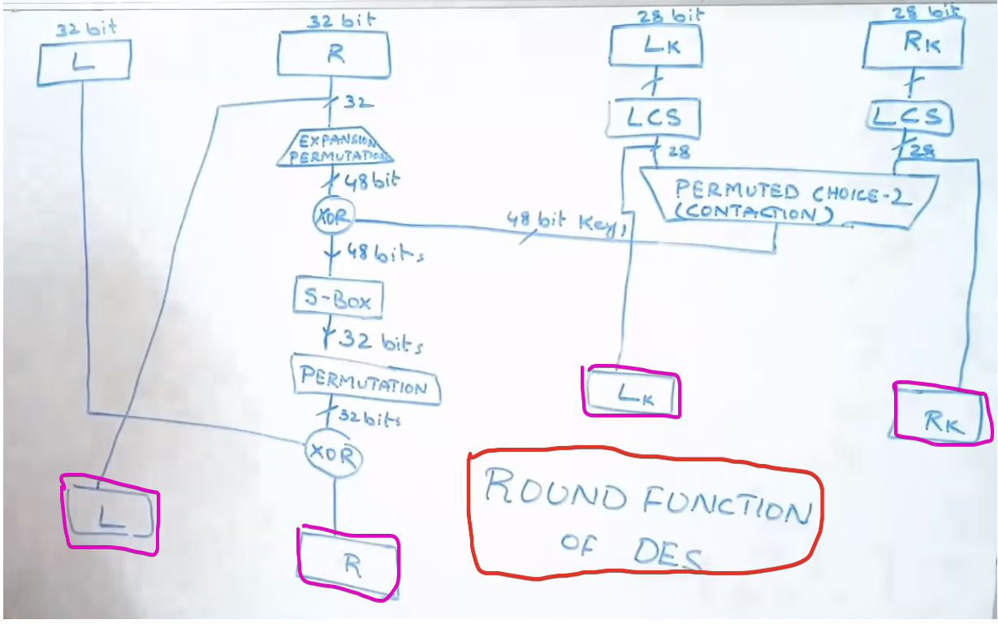

The same procedure is repeated for 15 times, Actually 16 times (R1 to R16)

## **After 16 Rounds**

Input 🡪 64 bits from Round-16

Output 🡪 Cipher Text

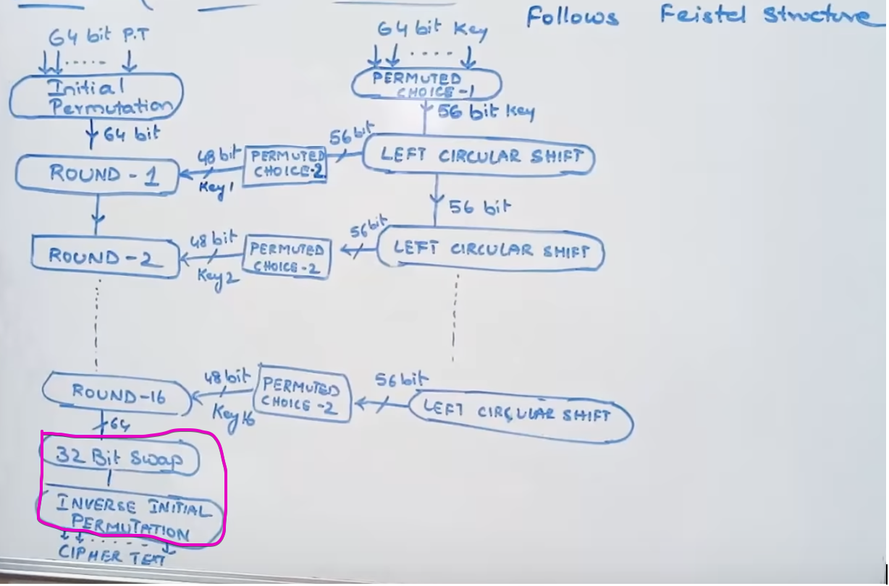



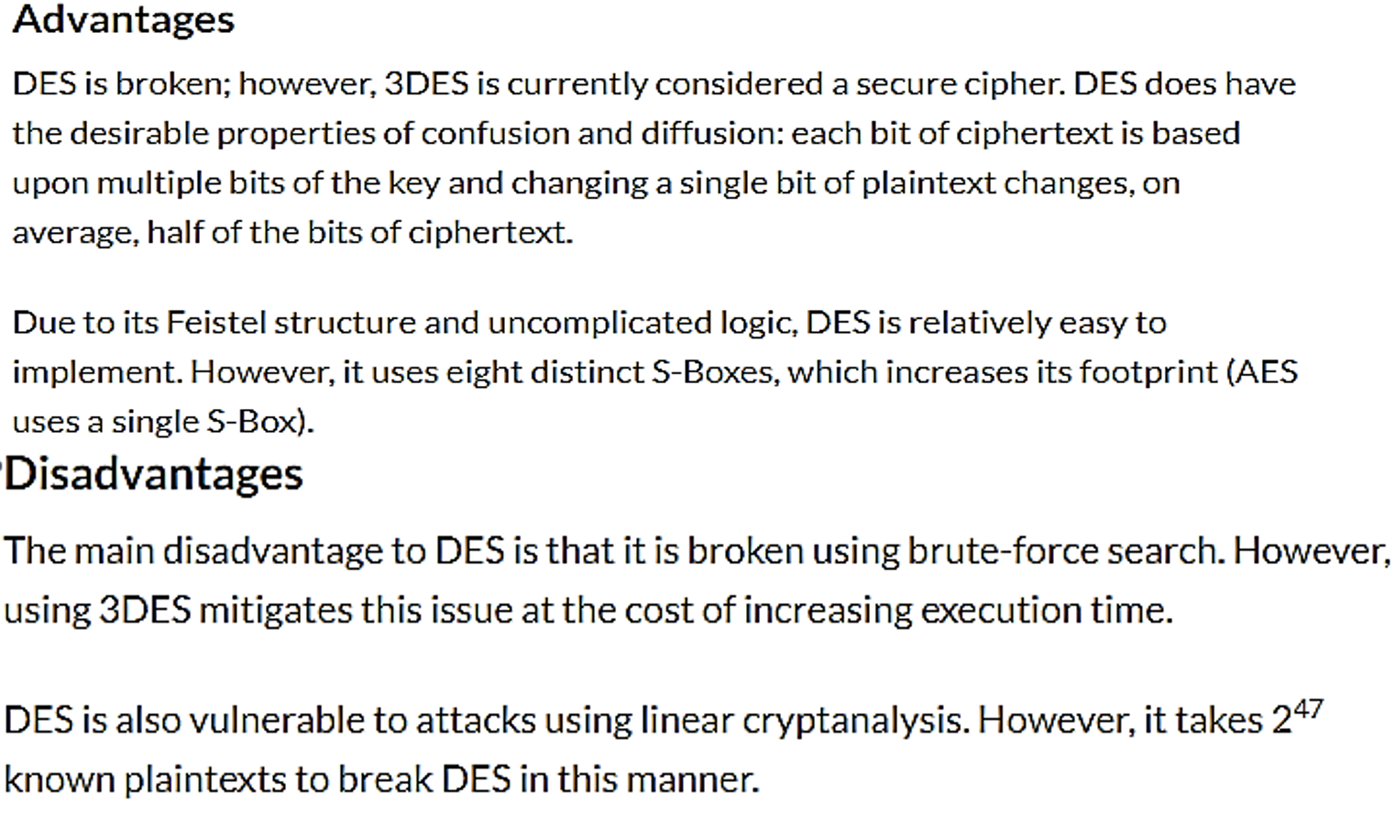

References  
https://www.youtube.com/watch?v=SaZGjQBItBc